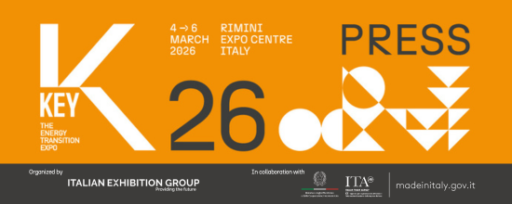

press release
(English translation)

IEG, KEY 2026 GUIDES THE GLOBAL ENERGY TRANSITION.
THE FOCUS OF THE NEXT EDITION: EFFICIENCY AS THE GREEN REVOLUTION DRIVER
- IEG’s (Italian Exhibition Group) leading event in Europe, Africa and the Mediterranean basin is scheduled to be held from 4th to 6th March 2026 at Rimini Expo Centre, Italy
- New layout covering the entire Expo Centre: seven exhibition sectors, vertical thematic areas and spaces for innovation and green skills
- An increasingly international outlook with a focus on Europe, North and sub-Saharan Africa, the Balkans, and Turkey
Rimini (Italy), 10th September 2025 – KEY – The Energy Transition Expo continues its momentum. The IEG (Italian Exhibition Group) event, a benchmark in Europe, Africa and the Mediterranean basin for energy transition and efficiency, will be back for its fourth edition in a stand-alone format from 4th to 6th March 2026 at Rimini Expo Centre with increasingly international ambitions, confirming its role as a relational hub for the sector’s global community. A strategic global network at the service of decarbonisation from which to design a green future, capable of picking up on signs of change, predicting future trends and anticipating new market needs.
KEY 2026 will continue its efforts to promote meetings and discussions between key players in the energy sector and encourage dialogue with institutions, thus facilitating the creation of collaborations and synergies, with the aim of joining forces to boost the energy transition. It will also continue to provide a unique opportunity for companies and professionals to learn about cutting-edge technologies and the latest innovations on the market for rationalising consumption and reducing the energy and environmental impact of their activities.
With a full and varied conference programme, the event will offer training, information, and professional development opportunities on the energy sector’s hottest and most current topics.

INTERNATIONAL SCOPE
One of the priorities of the next edition is to strengthen the show’s international profile. KEY 2026 will continue to focus on the African continent, particularly on the countries in North and sub-Saharan Africa, without forgetting Turkey and Europe, with a special focus on Germany, Spain, the UK, Poland, Serbia and the Balkan region. With this objective in mind, the event was presented, together with Ecomondo 2025, during a three-stage roadshow on 8th July in Cairo, 9th September in Belgrade and 11th September in Warsaw.

NEW LAYOUT FOR THE ENTIRE EXPO CENTRE
For the first time, KEY will occupy every hall at Rimini Expo Centre, strengthening the transversal and integrated vision that makes it unique in the European exhibition scene. The new layout will still be divided into seven distinct and recognisable, yet interconnected, thematic areas.
The areas dedicated to photovoltaics, wind power, energy storage, energy efficiency, electric mobility, and sustainable cities will be joined by:
- HYPE – Hydrogen Power Expo supported by Hydrogen & Fuel Cells: the hydrogen show organized by Italian Exhibition Group and Hannover Fairs International GmbH (HFI), the Italian branch of Deutsche Messe AG;
- Su.port – Sustainable Ports for Energy Transition: focus within the wind power halls on the importance of electrifying port quays for the sustainability of the maritime sector, cold ironing and ports as logistics hubs for the assembly and maintenance of floating renewable energy farms and hydrogen storage and transportation;
- Innovation District featuring a selection of innovative Italian and international green start-ups and SMEs, resulting from a Call for Start-ups. The Green Jobs&Skills project will also be in this district to favour the encounter between supply and demand for jobs in the field of sustainable skills. Moreover, the Lorenzo Cagnoni Innovation Award will be presented to the three start-ups at KEY with the highest innovative potential and to the seven exhibitors with the most cutting-edge projects, one for each of the event’s product sectors.
ENERGY EFFICIENCY AT THE HEART OF THE TRANSITION
Great attention to the topic of energy efficiency, in both the industrial and residential sectors, as a transition-enabling cornerstone. In the larger and newly arranged Energy Efficiency area, the zones dedicated to the Sustainable Building District, in partnership with Green Building Council Italia, and to Federcostruzioni, KEY's new partner which groups together the most important production categories of the entire construction, infrastructure, materials, engineering and systems market and which will bring the entire Italian construction supply chain to the show, have been confirmed.

KEY’S SECOND CALL FOR PAPERS
KEY fuels the debate on the global sustainable future by supporting research. For the second year running, a Call for Papers, open to universities, companies, research bodies and associations, including those not present among the exhibitors, was launched to present a project or describe a successful experience in the field of energy and climate transition. The 25 selected abstracts will be published in a special issue of the scientific journal QualEnergia Science, promoted by KEY - The Energy Transition Expo and published by Editoriale La Nuova Ecologia with the support of Italian Exhibition Group. The issue will be officially presented during KEY 2026.

KEY CHOICE – Unlock the future of PPAs
Once again for 2026, KEY CHOICE – Unlock the future of PPAs will take place prior to the event. This B2B KEY - The Energy Transition Expo event dedicated to Power Purchase Agreements is organized by IEG (Italian Exhibition Group) in collaboration with Elemens, and is scheduled to take place on Tuesday 3rd March 2026 at Rimini’s Palacongressi Conference Centre.

DPE – INTERNATIONAL ELECTRICITY EXPO
In conjunction with KEY, the new edition of DPE - International Electricity Expo will also be back. This event is organized by Italian Exhibition Group in collaboration with the Distributed Generation Association - Engines, Components, Generating Sets, a confederate of ANIMA Confindustria - and the ANIE Federation, dedicated to the electrical generation, transmission, distribution, safety and automation ecosystem.

ABOUT KEY 2026
Qualifica: Fiera internazionale; Organizzazione: Italian Exhibition Group S.p.A.; Periodicità: annuale; Edizione: 4°; Date: 4-6 marzo 2026; mail keyenergy@iegexpo.it; Website: http://www.key-expo.com; Facebook: https://www.facebook.com/keyexpo/; Instagram: https://www.instagram.com/key_expo/; LinkedIn: https://www.linkedin.com/company/keyenergy/

PRESS CONTACT KEY - ITALIAN EXHIBITION GROUP
head of media & corporate communication: Elisabetta Vitali; press office manager: Marco Forcellini, Pier Francesco Bellini; international press office coordinator: Silvia Giorgi; press office coordinator: Luca Paganin; press office specialists: Nicoletta Evangelisti, Mirko Malgieri; media@iegexpo.it

MEDIA AGENCY: Smartitaly Communications
Sara Scatena, s.scatena@smartitaly.it, mob. +39 338 7836985; Francesca Pericolo, f.pericolo@smartitaly.it, mob. +39 327 986 1860

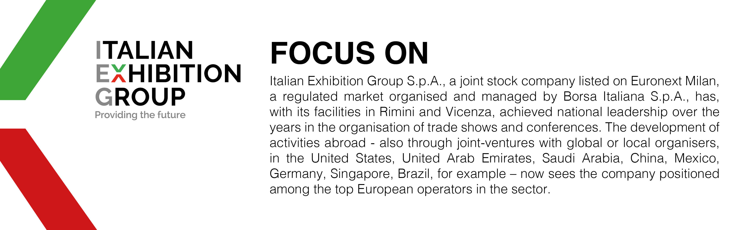

This press release contains forecast elements and estimates that reflect the management’s current opinions (“forward-looking statements”), particularly regarding future management performance, realization of investments, cash flow trends and the evolution of the financial structure. For their very nature, forward-looking statements have a component of risk and uncertainty, as they depend on the occurrence of future events. The effective results may differ (even significantly) from those announced, due to numerous factors, including, only by way of example: food service market and tourist flow trends in Italy, gold and jewellery market trends, green economy market trends; the evolution of raw material prices; general macroeconomic conditions; geopolitical factors and evolutions in the legislative framework. Moreover, the information contained in this release does not claim to be complete, and has not been verified by independent third parties. Forecasts, estimates and objectives contained herein are based on the information available to the Company as at the date of this release.

