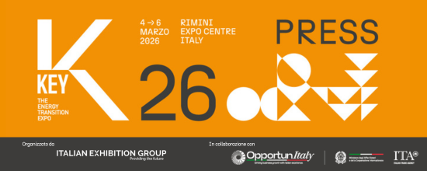

press release

IEG, KEY – THE ENERGY TRANSITION EXPO AT FULL STEAM AHEAD
+10% TOTAL VISITORS WITH +9% FROM ABROAD CLOSE THE 2026 EDITION
- Italian Exhibition Group’s energy transition event ended today at Rimini Expo Centre
- Over 1,000 exhibitors, of which 320 international
- 530 hosted buyers and delegations from 59 countries consolidate the event's role as a global energy hub
Rimini, 6th March 2026 – Three days of great exhibits, meetings, discussions and dialogues to map the new direction of the global energy future.

KEY – The Energy Transition Expo, IEG’s (Italian Exhibition Group) event of reference in Europe, Africa, and the Mediterranean basin on energy transition, came to a close today at Rimini Expo Centre after another intense edition full of new developments with results exceeding expectations.
Total attendance grew by 10%, with foreign visitors up by 9% and a strong presence of investors.
Covering 125,000 square meters of exhibition space and 24 halls, more than 1,000 exhibiting brands, of which 320 from abroad, showcased the most innovative products, solutions and technologies in the seven energy transition sectors.
530 hosted buyers and delegations from 59 countries were in attendance thanks to the support of the Italian Trade Agency (ITA) and the Ministry of Foreign Affairs and International Cooperation (MAECI). 412 journalists from around the world were accredited.

The event, inaugurated on Wednesday, 4th March by the Minister of Environment and Energy Security, Gilberto Pichetto Fratin, showcased European and non-European industrial and technological expertise with enormous enthusiasm throughout the entire Expo Centre while also promoting international cooperation, particularly with the African continent in the new Africa Investment HUB area.

With 160 high-quality and rigorously scientific conferences, KEY 2026 confirmed its status as one of Europe's most important energy events, standing out due to the completeness of its exhibition and content. These include the importance of energy efficiency for decarbonization, storage, and the use of artificial intelligence to optimize electricity grids, predict energy production from renewable sources, and manage energy flows in real time.
A platform that has combined technological innovation and finance, promoting dialogue between engineers, technology developers, investors, and institutions with the aim of making projects bankable and accelerating their implementation, thereby reducing risk. Among the requests that have emerged from associations and industries is the need to increase network flexibility and adopt clear rules that promote investment and competitiveness in order to transform the energy transition from a distant prospect into reality.
Great attention was paid to the topic of finance, new financial and investment models, capital for the implementation of renewable projects, and innovative tools for controlling energy costs, such as new forms of financing, green bonds, bonds for sustainable projects, and participatory models involving citizens, businesses, and communities.

Innovation and green jobs were the focus of the Innovation District with 32 innovative start-ups and SMEs and the Green Jobs&Skills initiative, which fostered the encounter between job supply and demand in the field of sustainability. The Lorenzo Cagnoni Innovation Award was presented to seven start-ups and seven KEY exhibitors for their most innovative projects, one for each of the event’s product categories.

DPE – INTERNATIONAL ELECTRICITY EXPO
In conjunction with KEY, the new edition of the DPE – International Electricity Expo also took place. This specific event on the electricity generation, transmission, distribution, safety and automation ecosystem, is organised by Italian Exhibition Group in collaboration with the Distributed Generation Association – Motors, Components, Generating Sets, a confederate of ANIMA Confindustria, and Federazione ANIE – which represents companies operating in the electrical engineering and electronics supply chains and industrial general contractors within the Confindustria system.

KEY CHOICE - Unlock the future of PPAs
On Tuesday, 3rd March, at Rimini’s Palacongressi Conference Centre, KEY was preceded by a successful new edition of KEY CHOICE - Unlock the future of PPAs, KEY – The Energy Transition Expo’s B2B event on Power Purchase Agreements, organised by Italian Exhibition Group in collaboration with Elemens.

KEY will be back at Rimini Expo Centre from 10th to 12th March 2027.

ABOUT KEY 2026
Event: International trade show; Organisation: Italian Exhibition Group S.p.A.; Frequency: annual; Edition: 4th; Dates: 4-6 March 2026; mail keyenergy@iegexpo.it; Website: http://www.key-expo.com; Facebook: https://www.facebook.com/keyexpo/; Instagram: https://www.instagram.com/key_expo/; LinkedIn: https://www.linkedin.com/company/keyenergy/

PRESS CONTACT KEY - ITALIAN EXHIBITION GROUP
head of media & corporate communication: Elisabetta Vitali; press office manager: Pier Francesco Bellini, Marco Forcellini ; international press office coordinator: Silvia Giorgi; press office coordinator: Luca Paganin; press office specialists: Nicoletta Evangelisti, Mirko Malgieri; media@iegexpo.it

MEDIA AGENCY: Smartitaly Communications
Sara Scatena, s.scatena@smartitaly.it, mob. +39 338 7836985; Francesca Pericolo, f.pericolo@smartitaly.it, mob. +39 327 986 1860

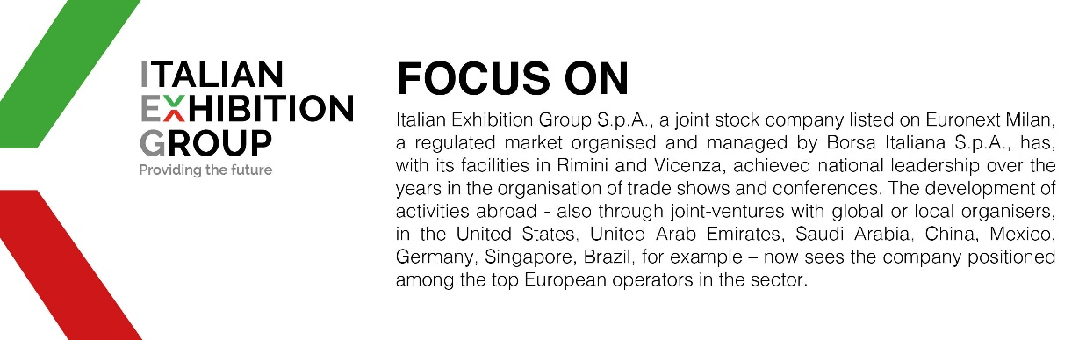

This press release contains forecast elements and estimates that reflect the management´s current opinions (´forward-looking statements´), particularly regarding future management performance, realization of investments, cash flow trends and the evolution of the financial structure. For their very nature, forward-looking statements have a component of risk and uncertainty, as they depend on the occurrence of future events. The effective results may differ (even significantly) from those announced, due to numerous factors, including, only by way of example: food service market and tourist flow trends in Italy, gold and jewellery market trends, green economy market trends; the evolution of raw material prices; general macroeconomic conditions; geopolitical factors and evolutions in the legislative framework. Moreover, the information contained in this release, doe not claim to be complete, and has not been verified by independent third parties. Forecasts, estimates and objectives contained herein are based on the information available to the Company as at the date of this release.

