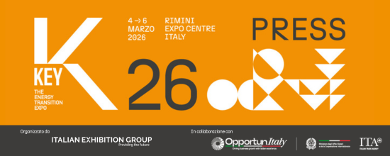

press release no. 7

KEY – THE ENERGY TRANSITION EXPO: HOW TO GET TO AND AROUND RIMINI

Rimini, February 23, 2026 – Italian Exhibition Group provides operators and visitors with a series of mobility services for getting to KEY – The Energy Transition Expo, ensuring easy journeys to and from Rimini Expo Centre on the days of the event from 4th to 6th March.

Entrances to the Expo Centre: South (via Emilia, 155), East (Via Costantino il Grande) and West (via San Martino in Riparotta).
Opening times: Wednesday 4th and Thursday 5th March, from 9.30 am to 6.30 pm, and Friday 6th March, from 9.30 am to 6 pm.
Tickets: entry subject to prior registration. Tickets purchased online before the show by registering on this link cost: 18 € (1 day) or 30 € (3 days). Tickets purchased online during the show by registering on this link cost: 25 € (1 day) or 40 € (3 days). Tickets purchased at the ticket office during the show cost: 28 € (1 day) or 45 € (3 days). Tickets for schools and university students cost 5 €.
Helpdesk tickets: for assistance, please call +39 0541 744555, operational from Monday to Friday from 9 am to 1 pm, or send an email to helpdesk.rn@iegexpo.it, or fill out the form at this link.
Services for people with disabilities: Italian Exhibition Group ensures easy accessibility for all visitors. The Expo Centre is totally accessible. Entry is free of charge for people with disabilities + one escort upon prior presentation at the ticket office. The STATION, SOUTH 1-2-3-4, EAST 3, and WEST 1-2 car parks have disabled parking facilities.

HOW TO GET TO THE EXPO CENTRE
Car: from the A14 Bologna-Bari-Taranto motorway, exit Rimini North (6 km).
Parking: cars can be left in the SOUTH 1-3/WEST 3-4-5 car parks (where the fee can also be paid automatically using a Telepass or UnipolMove device) and EAST 4-5 parking facility. 12 charging stations are available for electric vehicles with a total of 24 sockets. 6 are in the SOUTH 1 car park, and 6 are in the WEST 1-2 car parks.

Train: Rimini Expo Centre includes the RiminiFiera internal railway station (active exclusively on event days) on the Milan-Bari line, 50 meters from the South Entrance and reachable by Trenitalia regional, Intercity and Frecce trains at discounted prices. Train timetables can be consulted at this link. Timetables may vary, we recommend checking on the www.trenitalia.it website.
Furthermore, on the days of the event, special trains run from Cattolica and Santarcangelo di Romagna to Rimini Fiera. Timetables can be consulted here link.
Rimini and RiminiFiera stations are also connected to each other with regional, Intercity and Frecce trains, or by public transport with line 9 bis Shuttle buses (DIRECT to Rimini Fiera-South Entrance) and line 9 (via Emilia-Fiera stop).
Services for people with disabilities: for passengers with disabilities and reduced mobility, RFI provides an assistance service, which must be booked at least 12 hours in advance. The service operates exclusively for assistance in getting on/off the train and does not include accompaniment inside the trade show. The meeting point is at the train station ticket office. Further information is available on the RFI website at this
link.

Plane: for those arriving from Spain, the LuxWing airline will be operating a direct flight between Madrid and Rimini. Flight times can be consulted and tickets purchased at this link.
Rimini Expo Centre is only 10km from “Federico Fellini” Rimini - San Marino International Airport, which is on the S.S. 16 Adriatica road, or on the line 9 bus route, bus stop via Emilia-Fiera.
Other airports from which to travel to the Expo Centre are:
- Bologna, about 120 km away, along the A14 motorway or via the Shuttle Italy Airport with a direct connection to Rimini Expo Centre, operational on event days. Connection with the city of Rimini is also always active (stops: Rimini Railway Station, Rimini Via Fada). Tickets can be purchased online or via the Shuttle Italy Airport App, available for iOS and Android devices, at a cost of 5€, or 30€ at the desk in the Arrivals Area of ​​the Airport and on board the bus. Timetables available here link.
- Forlì, with bus line 7 (Airport-Forlì Station) + train (Forlì Station-Rimini or Riminifiera Stations).
Numerous car hire and car with driver hire companies are located in the airport, as well as Taxis and private buses.
- Ancona/Falconara, about 90 km away, along the A14 motorway, or by train (from Castelferretti Falconara Airport Station) or by combining Aerobus Raffaello and train.
Numerous car hire and car with driver hire companies are located in the Arrival Hall at the airport, as well as Taxis.
- Milan Linate (350 km) and Milan Malpensa (400 km), along the A14 motorway or by high-speed train.
- Rome Fiumicino, about 360 km away, using the high-speed train with one change at Bologna station.
- Venice, Treviso and Bergamo, connected to RiminiFiera station on the Trenitalia railway line with one change at Bologna station.

Special free buses: The trade show can be reached from hotels in Rimini and the surrounding area with the following free Special Bus services.
- Special bus AB Rimini Marina Centro-Rimini Expo Centre
- Special bus CE Bellaria- Rimini Expo Centre
- Special bus D Riccione- Rimini Expo Centre

Public transport buses: the Expo Centre can be reached by taking the following public transport buses:
- Line 9: Rimini-Rimini Fiera railway stations (bus stop via Emilia-Fiera)
- Shuttle Line 9: Rimini-Rimini Fiera/South Entrance Stations (no intermediary stops)
- Line 5: San Mauro Mare (Rimini North)-Rimini Fiera
- Line 10: Miramare (Rimini South)-Rimini Fiera

Metromare: the Metromare public transport service also has a specific route for getting to the Expo Centre that connects the Rimini and Riccione railway stations in 23 minutes, making 15 intermediate stops and guaranteeing daily trips with a frequency of approximately every 15 minutes. Consultable timetables here.

Sharing mobility: the Expo Centre can also be reached by shared micromobility vehicles (bicycles and electric scooters) from KEY partners, Lime and Bit Mobility. The vehicle parking areas, marked with special signage, are located at the South Entrance and inside the WEST 1-2 car parks.
For the duration of the event and one day before and one day after, the promotional code LIMEXFIERA can unlock 2 Lime trips per day taking advantage of a €1 discount, while the promotional code KEYBIT2026 will allow new subscribers to the Bit Mobility service to take advantage of 20 minutes of free travel, which can also be used in multiple trips of shorter duration.

To rent a vehicle, simply download the app from Google Play Store or App Store, register, locate a nearby device and unlock it using the QR code.

Taxis and car with driver hire: the Expo Centre can be reached from anywhere in the city using the taxi service by calling (+39) 0541/50020, or Shuttle Italy Airport’s car with driver hiring service by calling 0541/600100 or booking the journey on this link.

Car hire: discounted fares are available with AVIS Autonoleggio.

Helicopter: the Expo Centre has a helipad suitable for the take-off and landing of any civil transport helicopter. For information: martina.mazzoli@iegexpo.it

To find out about all the services for getting to KEY 2026, please see the specific page on the website: www.key-expo.com/come-arrivare

ABOUT KEY 2026
Event: International trade show; Organisation: Italian Exhibition Group S.p.A.; Frequency: annual; Edition: 4th; Dates: 4-6 March 2026; mail keyenergy@iegexpo.it; Website: http://www.key-expo.com; Facebook: https://www.facebook.com/keyexpo/; Instagram: https://www.instagram.com/key_expo/; LinkedIn: https://www.linkedin.com/company/keyenergy/

PRESS CONTACT KEY - ITALIAN EXHIBITION GROUP
head of media & corporate communication: Elisabetta Vitali; press office manager: Marco Forcellini, Pier Francesco Bellini; international press office coordinator: Silvia Giorgi; press office coordinator: Luca Paganin; press office specialists: Nicoletta Evangelisti, Mirko Malgieri; media@iegexpo.it

MEDIA AGENCY: Smartitaly Communications
Sara Scatena, s.scatena@smartitaly.it, mob. +39 338 7836985; Francesca Pericolo, f.pericolo@smartitaly.it, mob. +39 327 986 1860

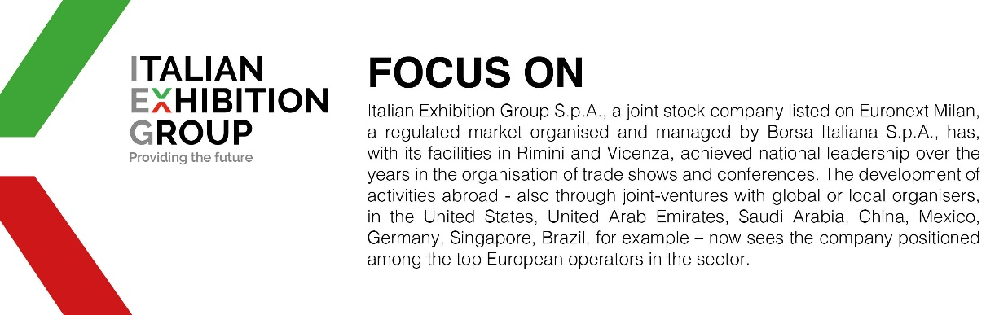

This press release contains forecast elements and estimates that reflect the management´s current opinions (´forward-looking statements´), particularly regarding future management performance, realization of investments, cash flow trends and the evolution of the financial structure. For their very nature, forward-looking statements have a component of risk and uncertainty, as they depend on the occurrence of future events. The effective results may differ (even significantly) from those announced, due to numerous factors, including, only by way of example: food service market and tourist flow trends in Italy, gold and jewellery market trends, green economy market trends; the evolution of raw material prices; general macroeconomic conditions; geopolitical factors and evolutions in the legislative framework. Moreover, the information contained in this release, doe not claim to be complete, and has not been verified by independent third parties. Forecasts, estimates and objectives contained herein are based on the information available to the Company as at the date of this release.

