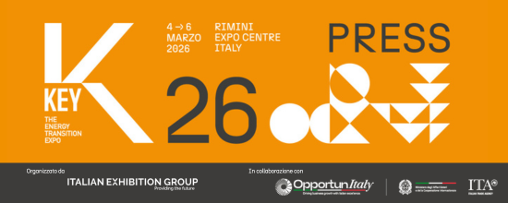

press release no. 6

KEY – THE ENERGY TRANSITION EXPO: NEW TOTAL EXPO CENTRE LAYOUT

- For the first time, the event will occupy almost the entire Rimini Expo Centre: 125,000 square metres in 24 halls, a new area for EPC Contractors and finance, and the Africa Investment HUB for networking and business meetings
- In the energy efficiency halls, HOME will reproduce a 100% smart, efficient and sustainable house
- Su.port – Sustainable Ports for Energy Transition and the Innovation District will be featured
- In hall A5, the new edition of DPE – International Electricity Expo

Rimini, February 23, 2026 – The exhibition space for KEY - The Energy Transition Expo, IEG’s (Italian Exhibition Group) energy transition event of reference in Europe, Africa and the Mediterranean basin, scheduled to take place from 4th to 6th March at Rimini Expo Centre, has been extended.

For the first time, the event will cover almost all the Expo Centre’s surface area, occupying approximately 125,000 square metres in 24 halls, further strengthening that diversification and exhibition completeness that make it unique in the panorama of European events on energy.

The new layout will still be divided into seven distinct and delineated thematic areas, but they will be interconnected to maximize existing synergies, thus improving visitor experience and favouring new business and networking opportunities.
New for the 2026 edition, an entire hall just for EPC Contractors (Engineering, Procurement & Construction) and finance within the solar energy area, and the Africa Investment HUB (hall D3), which will host several African sector associations from Egypt, Algeria, Morocco, Tunisia, the Ivory Coast, Senegal and South Africa, providing a space for networking and business meetings.

The event’s consolidated spaces and focuses will also be featured, such as the Su.port - Sustainable Ports for Energy Transition project, which debuted in 2025, and the Innovation District.

In conjunction with KEY, a new edition of DPE – International Electricity Expo will also take place occupying half of hall A5. The event, organised by Italian Exhibition Group in collaboration with Generazione Distributa - Engines, Components, Generating Sets, a confederate of ANIMA Confindustria - and the ANIE Federation, addresses the electrical generation, transmission, distribution, safety and automation ecosystem.

THEMED AREAS
KEY 2026 confirms its tried and tested format which features seven thematic areas: photovoltaics, wind, hydrogen, energy storage, energy efficiency, e-Mobility and Sustainable City.

SEC – SOLAR EXPO & CONFERENCES (halls C1-C7, D1-D3, D5 and B5) is the innovative technological showcase created in collaboration with Italia Solare, in which to explore the potential of solar in all its forms, from residential to utility scale, up to photovoltaics for industrial use and agrivoltaics. The area, in turn divided into product subcategories, will see the greatest growth, confirming the solidity of the market and the maturity of this technology, with a significant expansion of the areas dedicated to EPC Contractors, agrivoltaics and companies that deal with system fixing and assembly. SEC will host technology manufacturers and distributors specialised in photovoltaic modules and cells, inverters, fixing structures for system stability and durability, monitoring systems and components, as well as companies and operators providing services for photovoltaics, such as Operation & Maintenance, financial services, Utilities, energy traders and ESCos. Hall B5, adjacent to the area on energy storage, will host EPC Contractors and finance. SEC targets companies and trade associations, combining the exhibition part with insights on key topics such as Renewable Energy Communities, storage, critical material recovery and recycling, and eco-design.

KSE – KEY STORAGE EXPO: halls B7 and D7 will feature static storage for the residential and industrial sectors and for utility scale systems. In this area, which will not only exhibit electrochemical storage solutions, but also a wide range of innovative technologies, such as thermal storage and pumped hydroelectric systems, visitors will be able to discover advanced technologies and solutions for static energy storage with applications in the residential, commercial and industrial (C&I) sectors, as well as centralised storage and grid scale systems.

WEM – WIND EXPO FOR MED: the extended wind power area will develop in halls B1, B2 and B3 and will feature all its forms: onshore, offshore, mini-wind power and Renewable Energy Community projects that arise from this energy source. At WEM, manufacturers of onshore and offshore turbines, floating wind technology and components, companies active in solutions for revamping and repowering existing farms, O&M, asset and finance, and developers will be exhibiting. Utilities, wind farm managers, the most important electricity market operators, and investors will also be in attendance. Hall B3 will features the focus on Su.port - Sustainable Ports for Energy Transition on the importance of port dock electrification for maritime sector sustainability, cold ironing and ports as logistical hubs for the assembly and maintenance of floating renewable farms and hydrogen storage and transportation.

HYPE – HYDROGEN POWER EXPO: hall B4 will house HYPE - Hydrogen Power Expo, the hydrogen exhibition jointly organised by IEG and Hannover Fairs International GmbH (HFI), the Italian branch of Deutsche Messe AG, an international point of reference and moment of encounter for the sector’s main players to discuss and support new projects. HYPE will focus on the real applications of hydrogen by exhibiting technologies, projects, state of the art and future evolutions in the production, compression, storage and distribution of this extremely promising vector for decarbonization, especially in the hard-to-abate industrial and transport sectors. On display: infrastructure, devices and equipment, materials, components, systems and applications for fuel cell and power technologies, hydrogen mobility, hydrogen boilers, engineering, certification and finance companies, and measurement, analysis and testing systems.

EFFI – ENERGY EFFICIENCY EXPO: KEY 2026 will enhance the energy efficiency area, which will occupy half of hall A5, hall A7 and Halls A5-C5 and A7-C7. A place of exchange and growth in which to look closely at energy transition challenges and opportunities, analyse the most recent legislative proposals in support of Energy Service Companies, learn about the tools that encourage the adoption of innovative solutions in the energy sector, and discover services and solutions to electrify consumption, optimize production processes and promote an intelligent use of resources. With a transversal vision, the area will host companies, associations, institutions, public administrations and all stakeholders in the construction, residential and industrial sectors, including energy-intensive companies that see the energy transition as a strategic area of ​​investment. On display, solutions for cogeneration, trigeneration, micro-cogeneration and building efficiency, geothermal energy and heat pumps, solar thermal, digitalisation and energy management systems, smart buildings and building automation. Service companies, financial instruments for businesses and energy consultancy companies will also be in attendance. With the aim of promoting the culture of sustainable construction and the circular economy applied to the construction sector, this area will also feature the Sustainable Building District, organised in collaboration with Green Building Council Italia. KEY 2026’s new HOME — Healthy, Optimized, Measured, Efficient project will also reproduce a 100% smart, efficient and sustainable building acting as an educational and cultural space in which to find out how healthy and energy intelligent buildings are designed, built and measured.

EME – e-MOBILITY EXPO: halls A3 and A4 will be hosting EME – e-MOBILITY EXPO, the sector specifically for electric mobility and a point of reference for an audience of specialized visitors, public administration, retail sector operators, the industrial world and international buyers. Exhibitors from the public and private charging infrastructure sectors, Charging Point Operators (CPOs) and Mobility Service Providers (MSPs), will be present, as well as companies that deal with corporate fleet and goods transport electrification, batteries, and those involved in the electrical transition of the automotive ecosystem in general.

SUSTAINABLE CITY: in connection with EME, the Sustainable City area (halls A1 and A2) will act as an authentic laboratory of ideas for imagining and planning the future of cities, according to the smart city model. In this space, companies, associations, multiutilities and public administrations will be able to discuss, present and discover technologies and services for the efficiency and redevelopment of real estate assets, smart and sustainable lighting systems - thanks to collaboration with AIDI (Italian Lighting Association), ICT and IOT solutions and products for services, buildings, smart grids and sustainable mobility, electric and hybrid cars, car and bike sharing, smart parking, electric public transport and apps for integrated transport. There will also be services for Renewable Energy Communities and cutting-edge technologies, such as Artificial Intelligence, digital twin or augmented reality.

INNOVATION DISTRICT: in hall D4, the Innovation District will be hosting 32 Italian and international green start-ups and innovative SMEs selected from a Call for Start-ups, acting as an open innovation route to encourage product and service innovation and connect young enterprises with consolidated companies and investors in order to create new sustainable businesses.
As part of the Innovation District, the Green Jobs & Skills initiative will promote the encounter between job supply and demand by putting companies in search of specialised profiles in contact with students and young professionals looking for new job opportunities.

ABOUT KEY 2026
Event: International trade show; Organisation: Italian Exhibition Group S.p.A.; Frequency: annual; Edition: 4th; Dates: 4-6 March 2026; mail keyenergy@iegexpo.it; Website: http://www.key-expo.com; Facebook: https://www.facebook.com/keyexpo/; Instagram: https://www.instagram.com/key_expo/; LinkedIn: https://www.linkedin.com/company/keyenergy/

PRESS CONTACT KEY - ITALIAN EXHIBITION GROUP
head of media & corporate communication: Elisabetta Vitali; press office manager: Marco Forcellini, Pier Francesco Bellini; international press office coordinator: Silvia Giorgi; press office coordinator: Luca Paganin; press office specialists: Nicoletta Evangelisti, Mirko Malgieri; media@iegexpo.it

MEDIA AGENCY: Smartitaly Communications
Sara Scatena, s.scatena@smartitaly.it, mob. +39 338 7836985; Francesca Pericolo, f.pericolo@smartitaly.it, mob. +39 327 986 1860

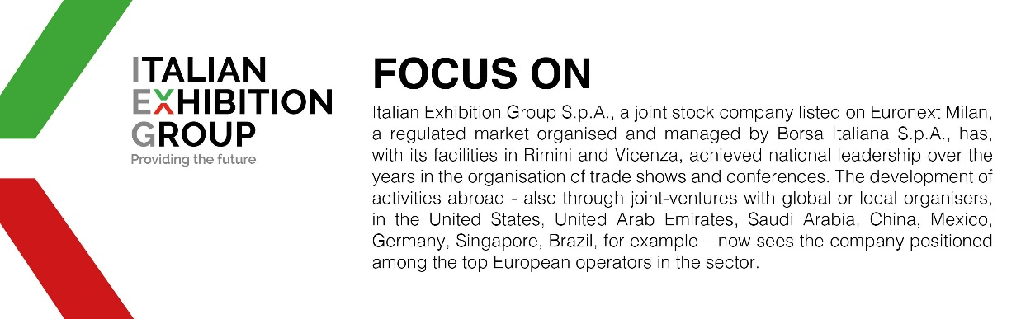

This press release contains forecast elements and estimates that reflect the management´s current opinions (´forward-looking statements´), particularly regarding future management performance, realization of investments, cash flow trends and the evolution of the financial structure. For their very nature, forward-looking statements have a component of risk and uncertainty, as they depend on the occurrence of future events. The effective results may differ (even significantly) from those announced, due to numerous factors, including, only by way of example: food service market and tourist flow trends in Italy, gold and jewellery market trends, green economy market trends; the evolution of raw material prices; general macroeconomic conditions; geopolitical factors and evolutions in the legislative framework. Moreover, the information contained in this release, doe not claim to be complete, and has not been verified by independent third parties. Forecasts, estimates and objectives contained herein are based on the information available to the Company as at the date of this release.

