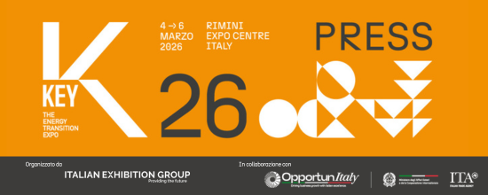

press release no. 2

KEY – THE ENERGY TRANSITION EXPO:
THE ENERGY HUB BECOMES INCREASINGLY GLOBAL

- Of the over 1,000 brands exhibiting at Italian Exhibition Group’s energy transition event, to be held from 4th to 6th March at Rimini Expo Centre, about 30% will be foreign
- Over 500 hosted buyers and delegations from around 50 countries are expected to attend
- Focus on cooperation with Africa: the Africa Investment HUB will make its debut in Hall D3
Rimini, February 23, 2026 – KEY – The Energy Transition Expo, Italian Exhibition Group's (IEG) leading event in Europe, Africa and the Mediterranean basin on energy transition, is strengthening its international profile.
This coming edition will accelerate the event’s growth, confirming its role as a global energy hub, and launch it even further beyond national and European borders. The aim is to extend dialogue between markets, institutions, and operators from all over the world and speed up the journey towards achieving decarbonisation targets.

Over 1,000 exhibiting brands are expected to attend, of which about 30% will be foreign (from 30 countries), as well as more than 500 hosted buyers and delegations from around 50 countries thanks to the support of the Ministry of Foreign Affairs and International Cooperation (MAECI) and the Italian Trade Agency (ITA).
Markets targeted by KEY 2026 will include North Africa and sub-Saharan Africa, as well as Turkey and Europe, with particular focus on Germany, Spain, the UK, Poland, Serbia and the Balkan area in general.
A Japanese delegation, involved in collaboration with H2IT and the Emilia-Romagna Region’s Clust-ER Greentech as part of the hydrogen partnership between the two countries and as a follow-up to IEG's mission to EXPO OSAKA, will also be attending for the first time.

For those travelling from Spain, the LuxWing airline will be operating a direct flight between Madrid and Rimini at times scheduled to easily coincide with international connections.

INITIATIVES FOR AFRICA
In line with Mattei Plan priorities, the growing centrality of the African continent in the global energy transition and in European energy and industrial policies, KEY aims to strengthen cooperation between Italy and Africa by connecting businesses, institutions, and investors to favour new synergies.
As part of the event’s new layout, Hall D3 will include the Africa Investment HUB, a brand new 126 m² area, which will host African industry associations from Egypt, Algeria, Morocco, Tunisia, the Ivory Coast, Senegal and South Africa and provide a specific space for networking and business meetings.
KEY will also be collaborating with Piantando, a B Corp that launches, finances, and monitors projects with a high social and environmental impact. During the event, and as part of Piantando's “Light Up” initiative, three solar street lamps will be installed in a village in Malawi.

INTERNATIONAL EVENTS
The event schedule, defined by KEY's Technical Scientific Committee, will include around 18 events in English for international visitors and operators.
Wednesday 4th March:
- Industrial Demand for Cleantech: Powering the Clean Industrial Deal, organised by Cleantech for Italy, which will bring together scientists, entrepreneurs, industrial leaders and institutions to define the priorities of a European industrial policy based on innovation, productivity and technological leadership. Italy's role in the context of the European Clean Industrial Deal will be central to the discussion.

Thursday 5th March:
- Strengthening collaboration between Italy and Japan on hydrogen technology innovations organised by H2IT, Cluster Greentech and JH2A – Japan Hydrogen Association: based on the Memorandum of Understanding between H2IT and JH2A, the event aims to strengthen the partnership between Italy and Japan in the hydrogen sector. The Italian Embassy in Tokyo, NEDO and industrial players from both countries will be participating.
- Electric Car Charging Networks: Where Do We Stand in Italy and Europe, organised by GSE and Motus-E: a discussion between operators, institutions, regulators and dealers to assess the opportunities and challenges for creating an efficient and widespread charging network in Italy and Europe
- Dual harvest, double trouble: Tackling EPC barriers in agrivoltaics design organised by PV Magazine, on the technical and engineering challenges from a European perspective
- Italy in the European and international agrivoltaics scene, organised by AIAS – Italian Sustainable Agrivoltaics Association
- How Norwegian offshore wind supply chain cluster members can support the bankability of FOW in Italy organized by Norwegian OHshore Wind (NOW)
- Towards a Circular Economy for Solar and Energy Storage: Strategies and Innovations in PV and Battery Recycling organized by ETA Florence, in collaboration with Ecomondo
- GERMAN-ITALIAN Energy Talk on hydrogen, organized by Hannover Fairs International, Hydrogen + Fuel Cells EUROPE, ITKAM, DIE GAS- UND WASSERSTOFFWIRTSCHAFT and H2IT
- Powering Italy’s Storage Decade: Markets, Technologies & the Road to 72 GWh organized by IBESA
- Bridging academia and industry: shared pathways for the energy transition organised by Sapienza University of Rome to foster debate among researchers, industry and policy makers, laying the foundations for the 2027 Scientific Conference
- Solar PV/Wind and Battery Storage Systems: the key to energy self-sufficiency, Driving Africa’s Energy Transition organised by Res4Africa
- Energy Communities Beyond Borders: Scalable Models from the Western Balkans organized by the Emilia-Romagna Region and ART-ER
- Türkiye’s Energy Transition and Investment Outlook: A Platform for Italian–Turkish Collaboration organized by Invest in Türkiye

Friday 6th March:
- Multiple financing instruments need to be scaled up to accelerate Africa’s energy future and to improve energy access organized by Res4Africa
- Italy’s Solar Transformation: Business Models, Policy Shifts & ESG for the Next Decade organized by IBESA
- Fit4Micro – Clean and Efficient MicroCHCP by Micro Turbine Based Hybrid Systems organized by ETA Florence in the DPE – International Electricity Expo schedule

The complete, constantly updated, KEY 2026 events programme is available at the following link:
www.key-expo.com/events

Events in English are available at this link: www.key-expo.com/english-events

ABOUT KEY 2026
Event: International trade show; Organisation: Italian Exhibition Group S.p.A.; Frequency: annual; Edition: 4th; Dates: 4-6 March 2026; mail keyenergy@iegexpo.it; Website: http://www.key-expo.com; Facebook: https://www.facebook.com/keyexpo/; Instagram: https://www.instagram.com/key_expo/; LinkedIn: https://www.linkedin.com/company/keyenergy/

PRESS CONTACT KEY - ITALIAN EXHIBITION GROUP
head of media & corporate communication: Elisabetta Vitali; press office manager: Marco Forcellini, Pier Francesco Bellini; international press office coordinator: Silvia Giorgi; press office coordinator: Luca Paganin; press office specialists: Nicoletta Evangelisti, Mirko Malgieri; media@iegexpo.it

MEDIA AGENCY: Smartitaly Communications
Sara Scatena, s.scatena@smartitaly.it, mob. +39 338 7836985; Francesca Pericolo, f.pericolo@smartitaly.it, mob. +39 327 986 1860

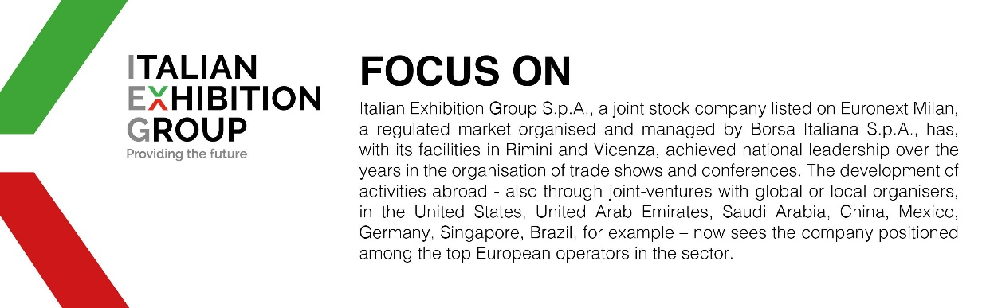

This press release contains forecast elements and estimates that reflect the management´s current opinions (´forward-looking statements´), particularly regarding future management performance, realization of investments, cash flow trends and the evolution of the financial structure. For their very nature, forward-looking statements have a component of risk and uncertainty, as they depend on the occurrence of future events. The effective results may differ (even significantly) from those announced, due to numerous factors, including, only by way of example: food service market and tourist flow trends in Italy, gold and jewellery market trends, green economy market trends; the evolution of raw material prices; general macroeconomic conditions; geopolitical factors and evolutions in the legislative framework. Moreover, the information contained in this release, doe not claim to be complete, and has not been verified by independent third parties. Forecasts, estimates and objectives contained herein are based on the information available to the Company as at the date of this release.

