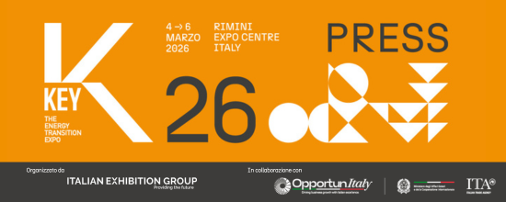

press release no. 1

KEY – THE ENERGY TRANSITION EXPO REWRITES THE ENERGY AGENDA.
FINANCE, COST CONTROL AND EPC CONTRACTORS FACE THE TRANSITION CHALLENGE

- The new edition of the Italian Exhibition Group event, from 4th to 6th March at Rimini Expo Centre
- An extended exhibition area: a total of approximately 125,000 square metres covering 24 halls and 7 themed areas
- More than 1,000 exhibiting brands, of which about 30% from abroad, and over 500 hosted buyers and delegations from around 50 countries
- More than 150 events programmed: the main focus will be on financial tools and solutions for reducing costs

Rimini, February 23, 2026 – A new edition of KEY – The Energy Transition Expo is scheduled to take place from 4th to 6th March at Rimini Expo Centre.
The event, organised by IEG (Italian Exhibition Group) and an energy transition reference point in Europe, Africa and the Mediterranean basin, confirms its role as the most important European platform for technologies, services and integrated solutions to accelerate decarbonisation

The event is growing in terms of participation, extension and content, reflecting the maturity of a market which, despite the uncertainties of the current context, remains solid. Furthermore, it is strengthening its role as a global hub open to international dialogue, standing out from other energy trade shows due to the diversification and completeness of its exhibition offer.

KEY 2026 brings the barycentre of strategic discussion back to Europe, restoring its leading role in the great ongoing transformation and enhancing its industrial and technological skills, research and the wealth of solutions already available to build a sustainable and competitive future.

More than 1,000 exhibiting brands are expected to attend, of which 30% will be from abroad, with a significant presence of companies from around 30 countries. Furthermore, over 500 hosted buyers and delegations from around 50 countries will be present thanks to collaboration with the Italian Trade Agency (ITA) and the Ministry of Foreign Affairs and International Cooperation (MAECI). A Japanese delegation is also expected to attend, involved in collaboration with H2IT and Emilia-Romagna Region’s Clust-ER Greentech as part of the hydrogen partnership between the two countries and as a follow-up to IEG's mission to EXPO OSAKA.

FINANCE TO SUPPORT THE TRANSITION
The central theme of KEY 2026 will be finance to support the energy transition with new tools to control energy costs.
The event will offer a comprehensive overview of new investment models in renewables and efficiency and innovative solutions to reduce bills by bringing into the discussion financial institutions, EPC Contractors, leading Italian and international companies, Associations and Institutions.
The focus on finance will also be reflected in the exhibition offer with an entire hall dedicated for the first time to EPC contractors and finance, which are becoming increasingly strategic in the construction of large renewable energy and utility-scale storage plants.

NEW LAYOUT TO TELL THE ENERGY SUPPLY CHAIN STORY
For the 2026 edition, KEY has extended its exhibition space to approximately 125,000 square metres, occupying almost all the Rimini Expo Centre with 24 halls divided into seven thematic areas: solar, wind, hydrogen, energy efficiency, energy storage, e-mobility and Sustainable City.
The solar sector has been extended the most, confirming the strength of the market and the maturity of this technology, with a significant expansion of the areas dedicated to EPC Contractors, agrivoltaics and companies involved in fixing and mounting systems for the installations.
The wind power area has also been increased and will include the focus Su.port – Sustainable Ports for Energy Transition on the role of ports as logistics hubs for the assembly and maintenance of floating farms and hydrogen storage and transportation.
The energy efficiency area, a pillar of KEY's role as transition enabler, has been enhanced and reorganised with a transversal vision of decarbonisation in both industry and the built environment. The halls for this sector will also feature KEY 2026's new HOME — Healthy, Optimised, Measured, Efficient project, an educational and cultural area that will reproduce a 100% smart, efficient and sustainable building, demonstrating how healthy and energy-efficient buildings are designed, constructed and measured.

COOPERATION WITH AFRICA
In line with Mattei Plan priorities and the growing centrality of the African continent in the global energy transition and in European energy and industrial policies, KEY aims to strengthen cooperation with Africa by connecting companies, institutions and investors to foster new synergies.
Res4Africa will be organising two events, scheduled for 5th and 6th March, dedicated to the continent’s energy self-sufficiency
Furthermore, the Africa Investment HUB area – a new entry at KEY 2026 – will host African industry associations from Egypt, Algeria, Morocco, Tunisia, the Ivory Coast, Senegal and South Africa, providing a space for networking and business meetings
During the event and as part of the collaboration between KEY and Piantando – B Corp, which initiates, finances and monitors projects with a high social and environmental impact – three solar street lamps will be installed in a village in Malawi.

SCIENTIFIC RIGOUR: THE CONFERENCE PROGRAMME
With a programme of more than 150 events featuring high-quality, rigorous content based on scientific data and evidence, of which 90 organised by the Technical Scientific Committee, KEY confirms its status as a place for open and strategic dialogue where skills, know-how and best practices will come together to support the energy transition.
Events scheduled will see the return of the KEY ENERGY SUMMIT and ITALIA SOLARE's ForumTech.
On Thursday 5th March, the Report on the state of energy sustainability in the construction supply chain will be presented in collaboration with FEDERCOSTRUZIONI. Moreover, KEY and Elemens will be organising the conference EPC and Finance: the new phase of renewables to connect banks and EPC Contractors with the aim of promoting new models of collaboration and reducing existing obstacles to the construction of renewable energy plants. On the same day, the Ministry of Environment and Energy Security, together with the United Nations Development Programme (UNDP) and UN Environment Programme (UNEP), will be organising Energy and Innovation: MASE International Cooperation for Energy Transition.

THE INNOVATION DISTRICT
Innovation and sustainable skills will be playing leading roles again in the Innovation District, an open innovation path that promotes product and service innovation, connecting young entrepreneurial realities, consolidated companies, and investors. The area will host 32 innovative Start-ups and SMEs selected from a Call for Start-ups, and will also feature the Green Jobs & Skills initiative, encouraging the encounter between job supply and demand.
On Wednesday 4th March, the Lorenzo Cagnoni Innovation Award will be given to seven exhibitors for their most innovative projects, one for each of the event’s product categories.
KEY CHOICE – Unlock the future of PPAs
On Tuesday 3rd March, the day before Key, Rimini’s Palacongressi Congress Centre will be staging KEY CHOICE – Unlock the future of PPAs, the B2B event organised by IEG in collaboration with Elemens, which will offer a comprehensive vision of the opportunities and challenges linked to the energy transition by providing a technical and strategic update, also in light of the most recent regulations.

DPE – INTERNATIONAL ELECTRICITY EXPO
The new edition of DPE – International Electricity Expo will also be back and in conjunction with KEY. The event, organised by Italian Exhibition Group in collaboration with the Distributed Generation Association – Motors, Components, Generating Sets, affiliated with ANIMA Confindustria – and the ANIE Federation, focuses on the generation, transmission, distribution, safety and electrical automation ecosystem.

ABOUT KEY 2026
Event: International trade show; Organisation: Italian Exhibition Group S.p.A.; Frequency: annual; Edition: 4th; Dates: 4-6 March 2026; mail keyenergy@iegexpo.it; Website: http://www.key-expo.com; Facebook: https://www.facebook.com/keyexpo/; Instagram: https://www.instagram.com/key_expo/; LinkedIn: https://www.linkedin.com/company/keyenergy/

PRESS CONTACT KEY - ITALIAN EXHIBITION GROUP
head of media & corporate communication: Elisabetta Vitali; press office manager: Marco Forcellini, Pier Francesco Bellini; international press office coordinator: Silvia Giorgi; press office coordinator: Luca Paganin; press office specialists: Nicoletta Evangelisti, Mirko Malgieri; media@iegexpo.it

MEDIA AGENCY: Smartitaly Communications
Sara Scatena, s.scatena@smartitaly.it, mob. +39 338 7836985; Francesca Pericolo, f.pericolo@smartitaly.it, mob. +39 327 986 1860

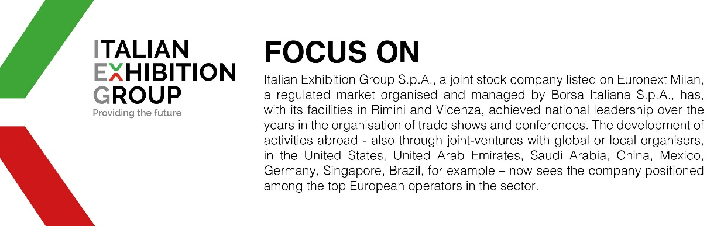

This press release contains forecast elements and estimates that reflect the management´s current opinions (´forward-looking statements´), particularly regarding future management performance, realization of investments, cash flow trends and the evolution of the financial structure. For their very nature, forward-looking statements have a component of risk and uncertainty, as they depend on the occurrence of future events. The effective results may differ (even significantly) from those announced, due to numerous factors, including, only by way of example: food service market and tourist flow trends in Italy, gold and jewellery market trends, green economy market trends; the evolution of raw material prices; general macroeconomic conditions; geopolitical factors and evolutions in the legislative framework. Moreover, the information contained in this release, doe not claim to be complete, and has not been verified by independent third parties. Forecasts, estimates and objectives contained herein are based on the information available to the Company as at the date of this release.

